**STRING METHODS**

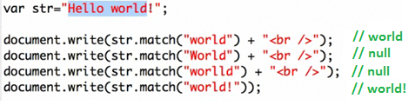



**x = 2+"2" == "2" +2 == "2"+"2" == "22"**

|  |  |
| --- | --- |
| **Method** | **Description** |
| [charAt()](http://www.w3schools.com/jsref/jsref_charat.asp) | Returns the character at the specified index |
| [charCodeAt()](http://www.w3schools.com/jsref/jsref_charcodeat.asp) | Returns the Unicode of the character at the specified index |
| [concat()](http://www.w3schools.com/jsref/jsref_concat_string.asp) | Joins two or more strings, and returns a copy of the joined strings |
| [fromCharCode()](http://www.w3schools.com/jsref/jsref_fromcharcode.asp) | Converts Unicode values to characters |
| [**indexOf()**](http://www.w3schools.com/jsref/jsref_indexof.asp) | Returns the position of the first found occurrence of a specified value in a string |
| [lastIndexOf()](http://www.w3schools.com/jsref/jsref_lastindexof.asp) | Returns the position of the last found occurrence of a specified value in a string |
| [match()](http://www.w3schools.com/jsref/jsref_match.asp) | Searches for a match between a regular expression and a string, and returns the matches |
| [**replace()**](http://www.w3schools.com/jsref/jsref_replace.asp) | Searches for a match between a substring (or regular expression) and a string, and replaces the matched substring with a new substring |
| [**search()**](http://www.w3schools.com/jsref/jsref_search.asp) | Searches for a match between a regular expression and a string, and returns the position of the match |
| [slice()](http://www.w3schools.com/jsref/jsref_slice_string.asp) | Extracts a part of a string and returns a new string |
| [split()](http://www.w3schools.com/jsref/jsref_split.asp) | Splits a string into an array of substrings |
| [substr()](http://www.w3schools.com/jsref/jsref_substr.asp) | Extracts the characters from a string, beginning at a specified start position, and through the specified number of character |
| [**substring()**](http://www.w3schools.com/jsref/jsref_substring.asp) | Extracts the characters from a string, between two specified indices |
| [**toLowerCase()**](http://www.w3schools.com/jsref/jsref_tolowercase.asp) | Converts a string to lowercase letters |
| [**toUpperCase()**](http://www.w3schools.com/jsref/jsref_touppercase.asp) | Converts a string to uppercase letters |
| [**valueOf()**](http://www.w3schools.com/jsref/jsref_valueof_string.asp) | Returns the primitive value of a String object |

**MATH FUNCTION**

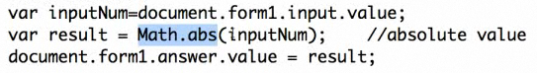

Math.round(var1)

Math.random()

Math.min(var1, var2, var3)

Matn.max(var1,var2,var3)

Math.sqrt(var1)

**var** number1 = Math.floor(Math.random()*11)

Math.floor: Devuelve el número entero más grande menor o igual que el número especificado.

**var y%x; // mod**

**Math.exp(a) // exp a**

**Math.pow(a,b) // a^b area = Math.PI * Math.pow(radio, 2);**